  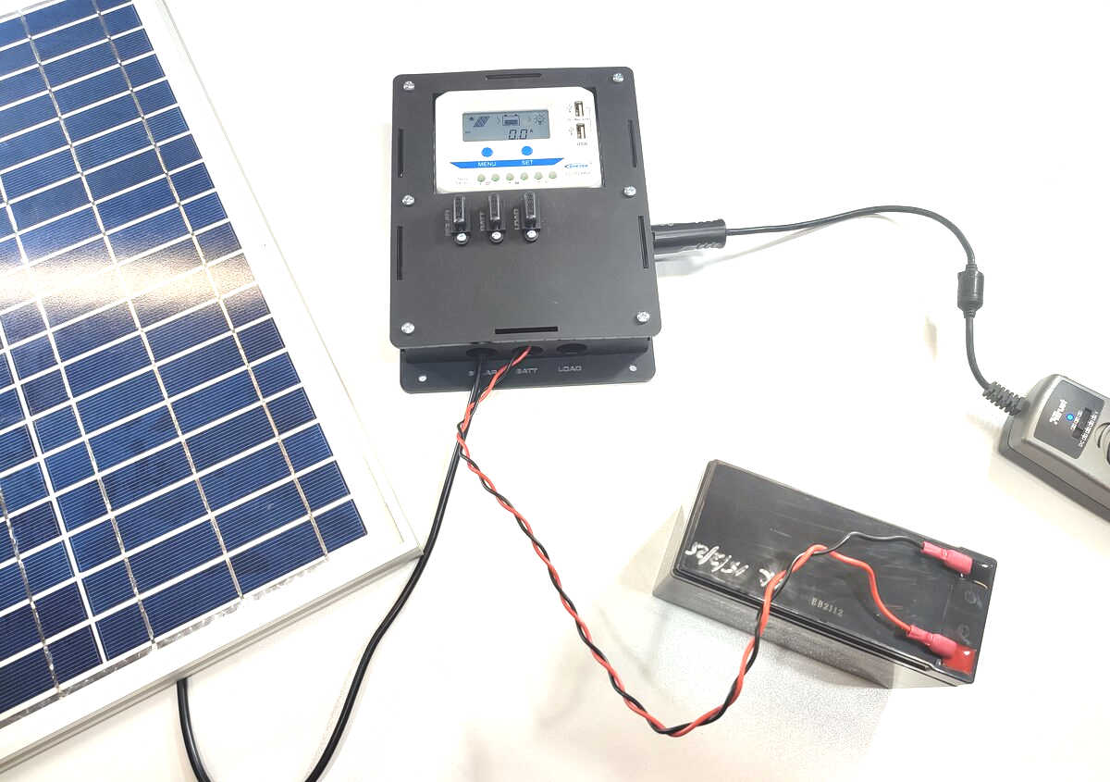 | DIY Solar Power System Instructions

Date: | 26/03/25 | Version: | 1.0 | By: | Matt Little

Take your shed, chicken coop or underground bat cave off-grid!

Get started with a simple solar power system. This kit builds a solar power regulation system to control the power from a solar panel to a 12V lead-acid battery. It provides outputs for your 12V and 5V (USB) loads.

This system is designed to make it it easy and neat to install a solar charge regulator along with fuses for safety and cable protection. There is a 12V DC car socket and terminal block output for small DC loads. The maximum load is 120W DC, so this is designed for small off-grid situations.

The solar charge controller is a good quality EPEVER VS1024AU (https://www.epever.com/product/vs-au-10-60a-pwm-charge-controller/) designed for PWM (pulse width modulation) charging of sealed, gel and flooded lead-acid batteries and up to 10A of solar input and DC output.

It is for people who have a small solar panel and lead-acid battery already. These are readily available and can be sized for different applications.

Please note: Solar panel is NOT included. Battery is NOT included.

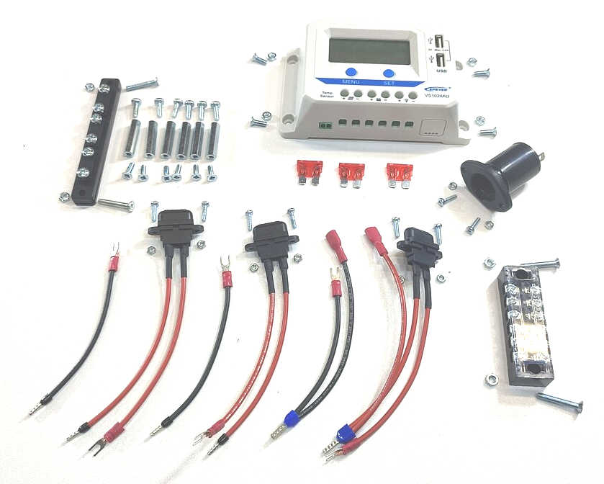
Parts included:
 |  | Fuse x 3 (10A) |  |  | Charge Controller (10A)
Cable
clamp
block
Cable  clamp  block |  |  |  |  |  |  |  | 12V Output Socket
Single connection wire x 2
Barrier Terminal Block
(10A)
Single wire fuse unit
x 2
 |  |  |  | Double connection wire | Double wire fuse unit
Note: Hardware listed on next image.

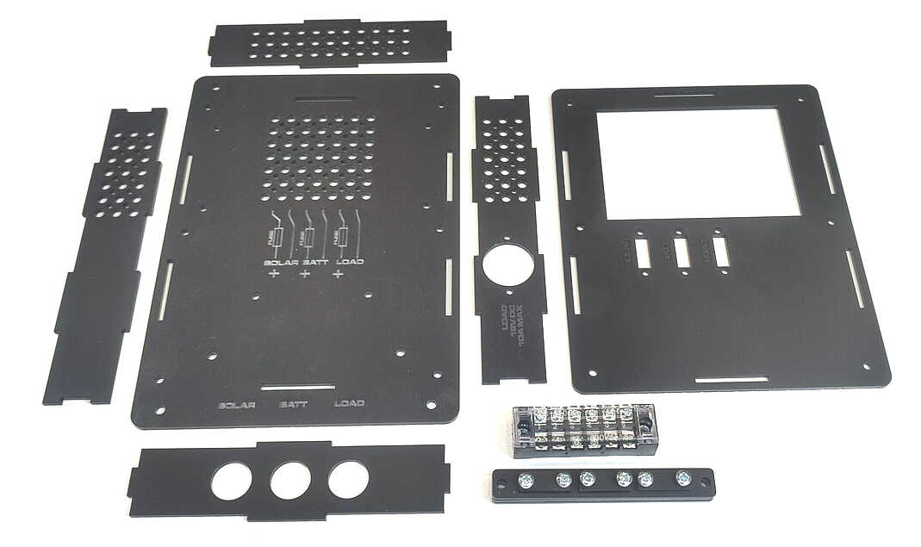
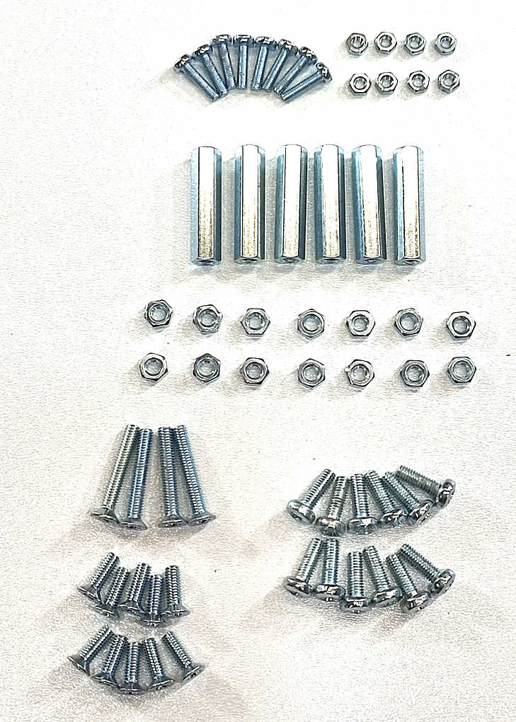
Enclosure Parts:
Top |  | Right hand side
 |  | Front
Left hand side
Back |  | Barrier Terminal Block
Lower |  | Cable clamp unit
M3 12mm screws x 8
 |  | M3 Nuts x8
M4 Hex spacer 30mm x 6
M4 Nuts x 14 |  | M4 10mm screws x 6
M4 22mm screws x 4 |  | M4 12mm screws x 6
M4 10mm countersunk screws x 10

Parts list:
Electrical Parts
Item | Quantity | Item | Quantity
Charge controller 10A  (EPEVER VS1024AU) | 1 | Barrier terminal block 6 way (10A) | 1
10A Blade automotive fuse | 3 | 12V Car socket | 1
Double connection wire (black) | 1 | Single connection wire (black) | 2
Double wire fuse unit (red) | 1 | Single wire fuse unit | 2
Hardware
Item |  |  | Quantity
Enclosure back (3mm laser-cut Perspex) |  |  | 1
Enclosure front (3mm laser-cut Perspex) |  |  | 1
Enclosure top (3mm laser-cut Perspex) |  |  | 1
Enclosure lower (3mm laser-cut Perspex) |  |  | 1
Enclosure left hand side (3mm laser-cut Perspex) |  |  | 1
Enclosure right hand side (3mm laser-cut Perspex) |  |  | 1
Cable clamp unit 6 pcs in total (3 long and 3 short) (3mm laser-cut Perspex) |  |  | 1
M3 12mm machine screws pan head |  |  | 8
M3 nuts |  |  | 8
M4 30mm metal hex spacers F-F |  |  | 6
M4 10mm machine screws countersunk head |  |  | 10
M4 22mm machine screws countersunk head |  |  | 4
M4 10mm machine screws pan head |  |  | 6
M4 12mm machine screws pan head |  |  | 6
M4 nuts |  |  | 14
Tools required:
 | 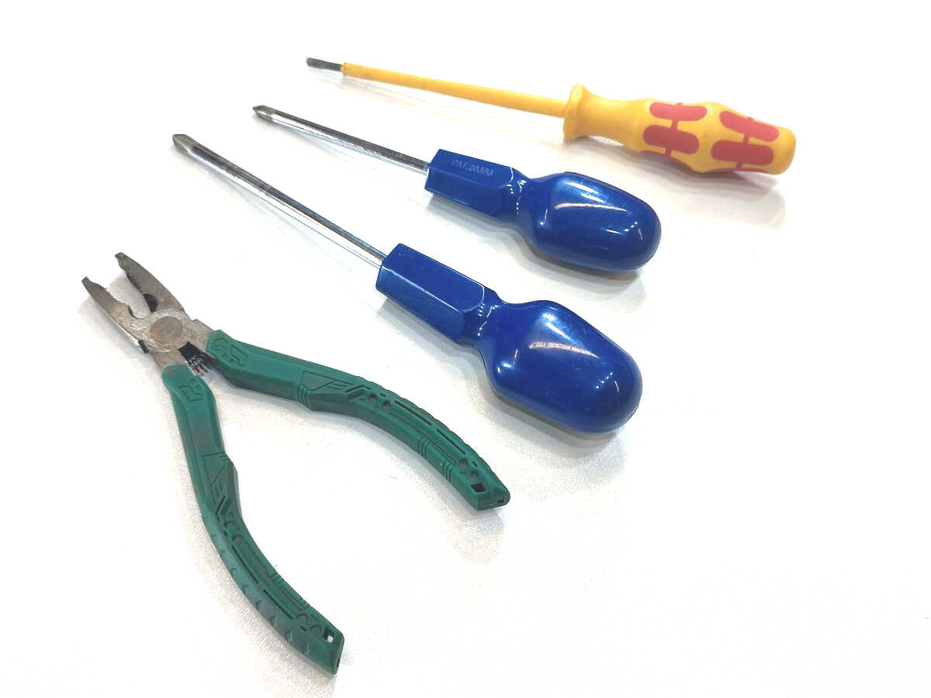
Flat head electrical screwdriver |  | Large pozi screwdriver
Small pozi screwdriver |  | Pliers

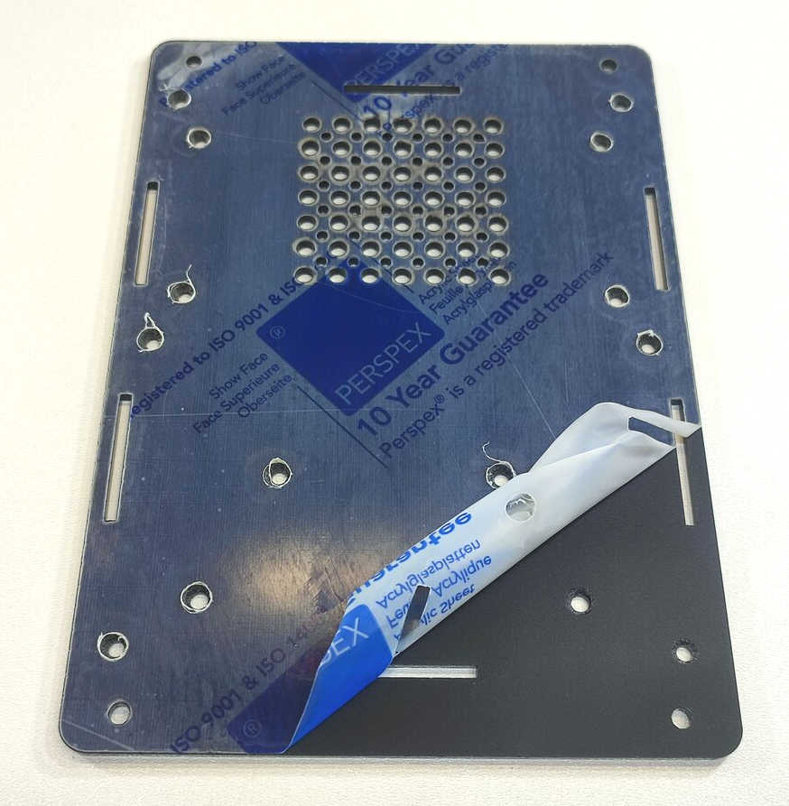
Instructions:
Step: 1 | Push out laser-cut parts and peel off protective layer
Sometimes not all the small laser-cut pieces have been removed. These can be pushed out using the point of a screwdriver. Only slight force should be required.  (Example plastic images shown)  There is a protective film on one side of ALL the laser cut plastic parts. This can be removed by peeling off the film. |  | 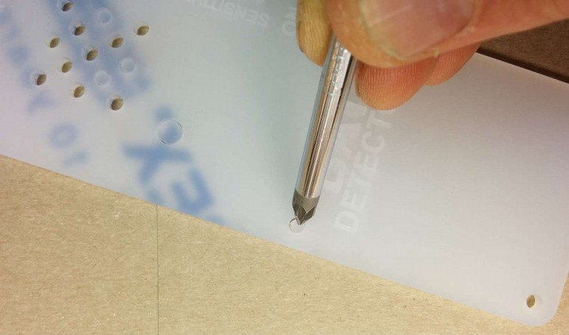

Step: 2 | Add charge controller to back plate
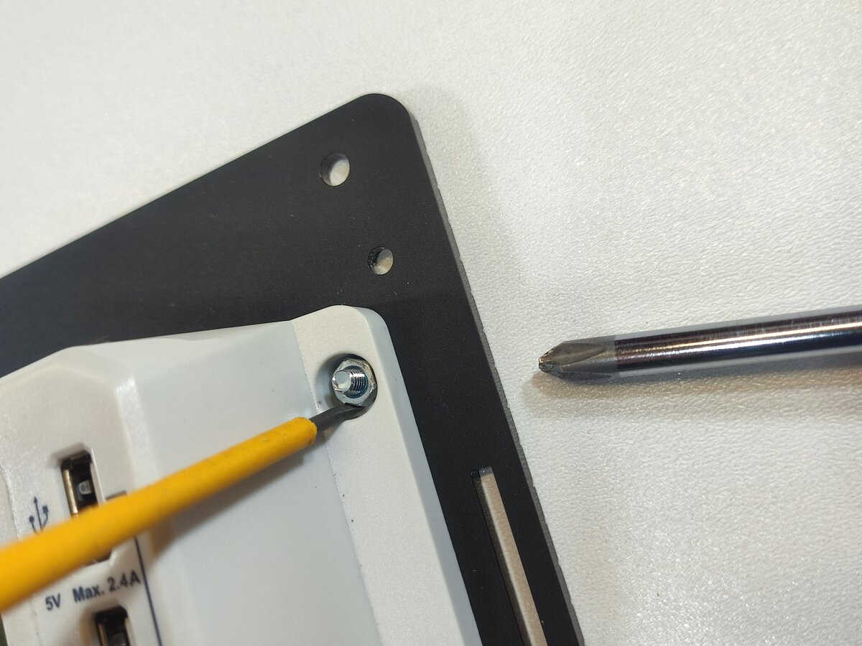  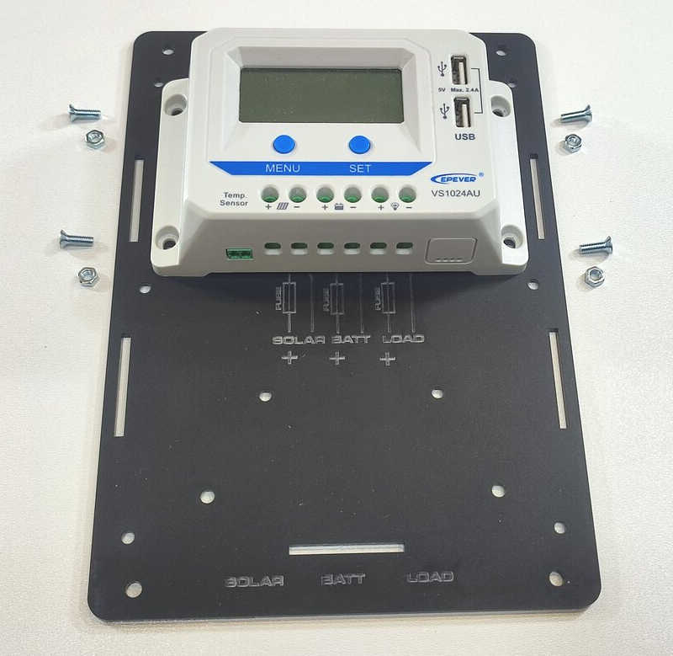  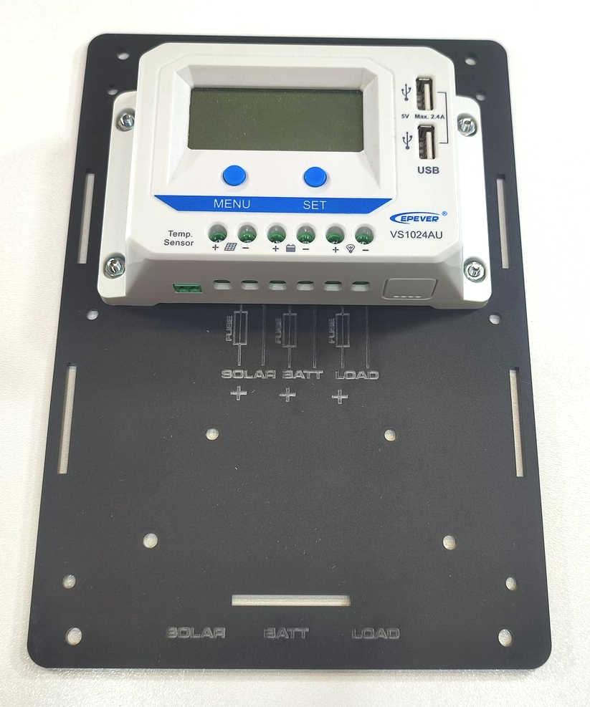 |  | Using 4 x M4 10mm countersunk screws and 4 x M4 nuts you can fit the charge controller to the back plate.  Ensure the engraved writing is visible on the same side as the charge controller.  On the opposite side there should be countersunk holes for the screw heads to fit into and hence lie flat.  You might find the nuts spin around rather than tighten.  To stop this use a small flat head screwdriver to hold the nut and stop it from rotating.  You can then tighten the screw from the back using a pozi screwdriver.

Step: 3 | Build cable clamp unit
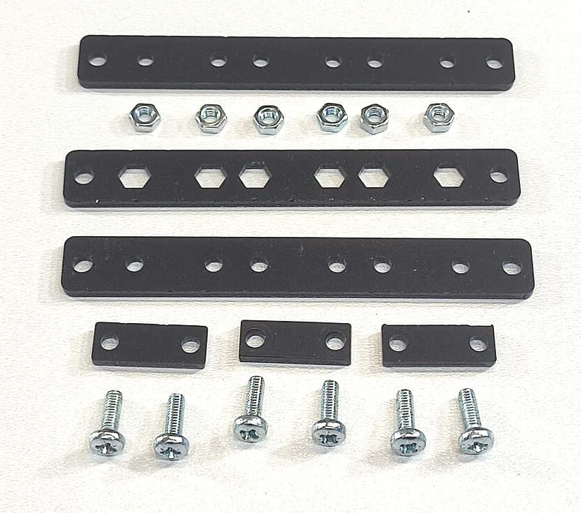  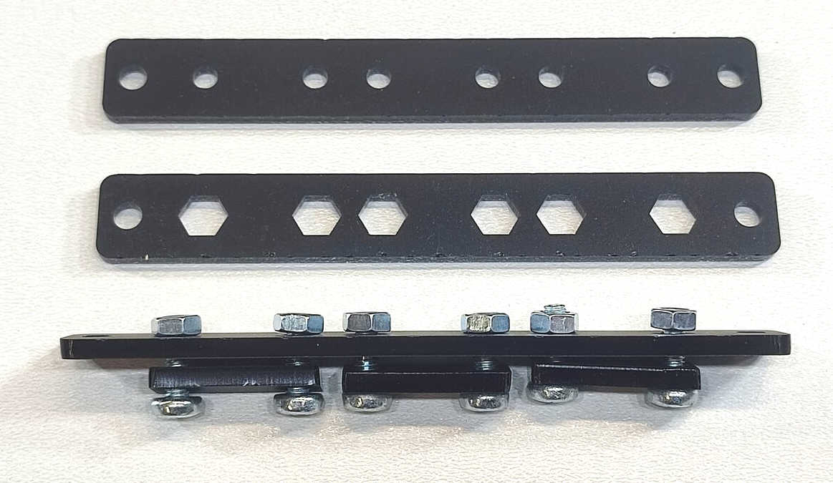  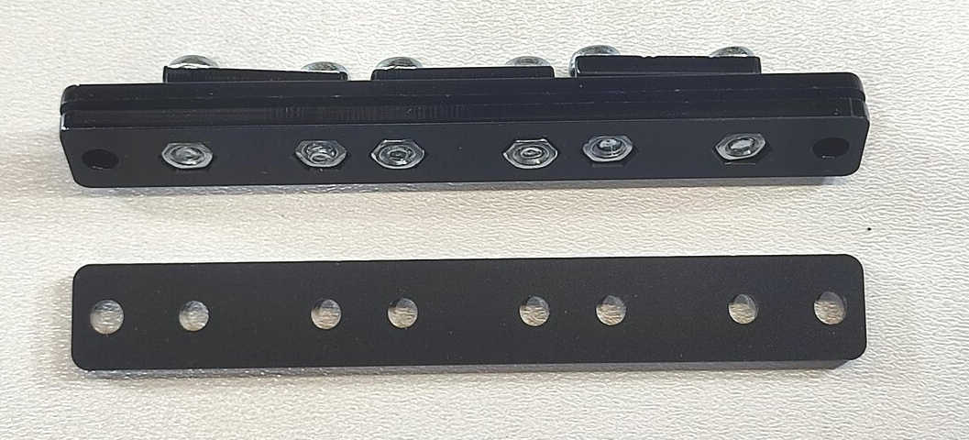  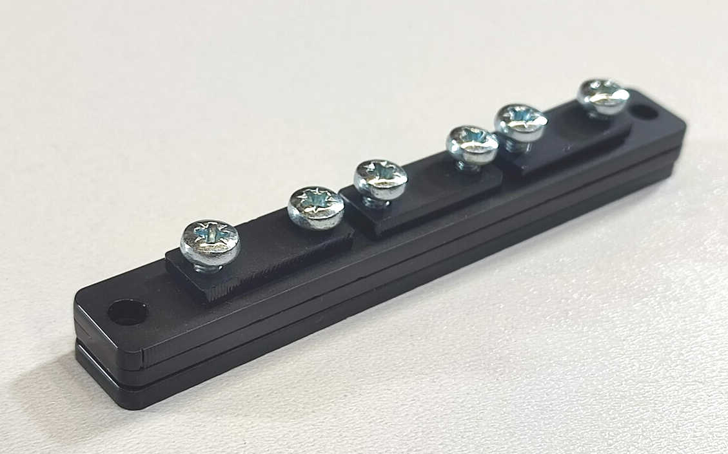 |  | Set out the parts for the cable clamp unit as shown here. You will need:  - 3 x long plastic pieces  - 3 x short plastic pieces  - 6 x M4 12mm screws  - 6 x M4 nuts  Using the M4 screws and nuts, hold the short pieces of plastic to one of the long pieces of plastic with round holes in it.  Do not fully tighten the screws/nuts.  Next use the long piece of plastic with hexagonal holes – fit this to cover the M4 nuts. You will need to align the nuts to make sure it fits.  Finally add the last long piece of plastic with round holes to the bottom of the ‘sandwich’.  The cable clamp is not ready to be attached to the back plate (next step).

Step: 4 | Add terminal black and cable clamp to back plate
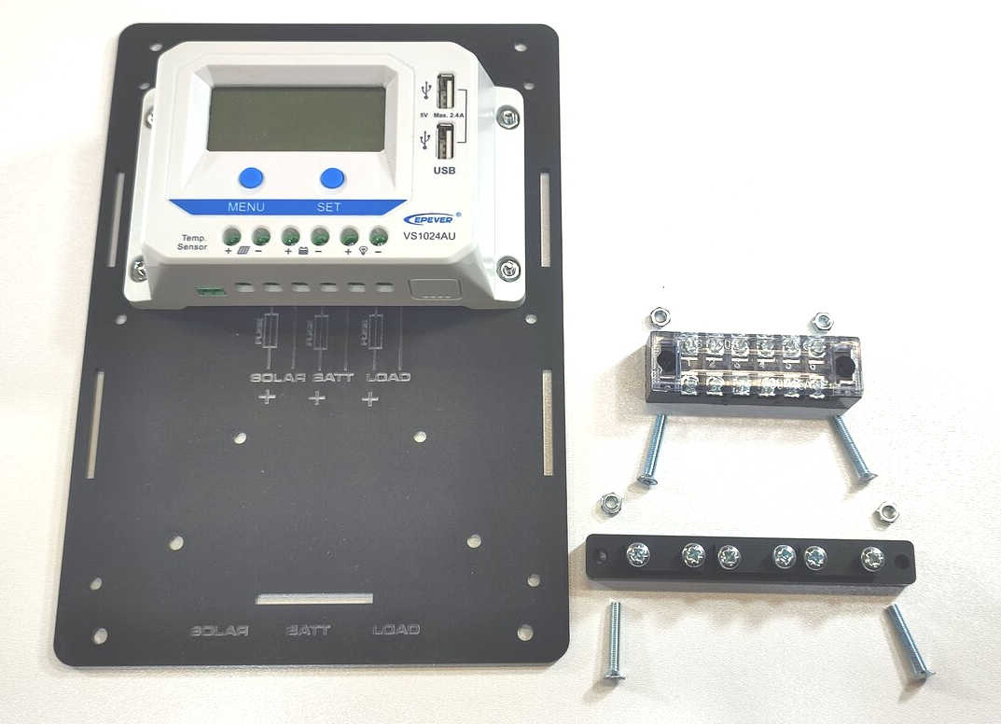  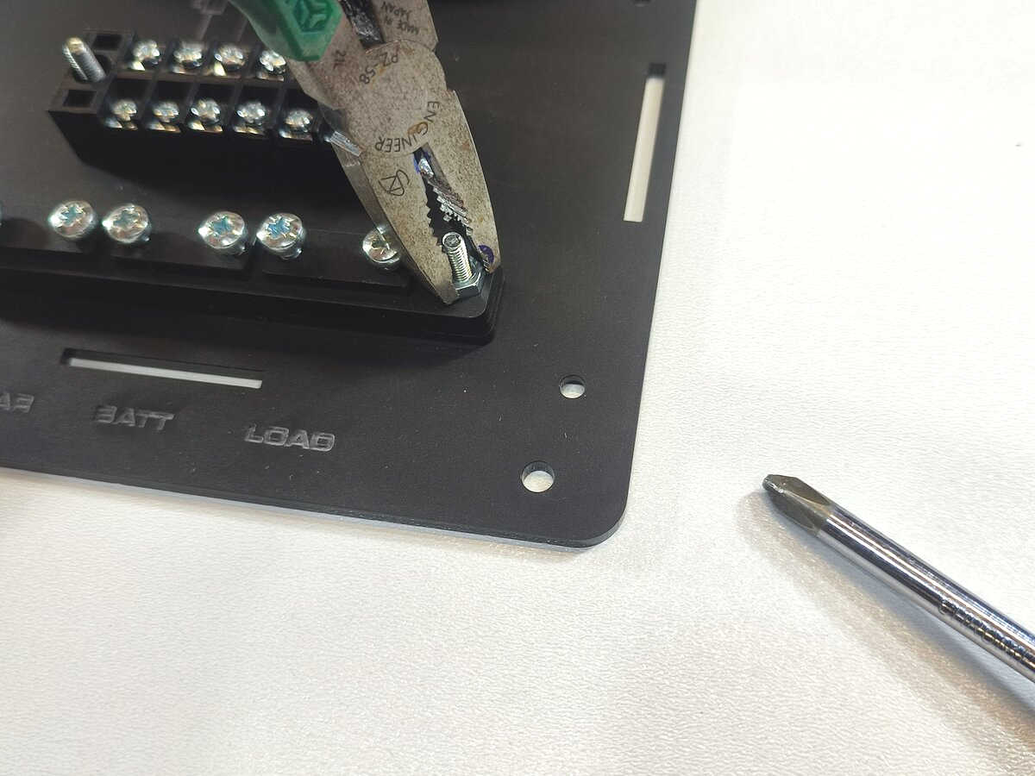  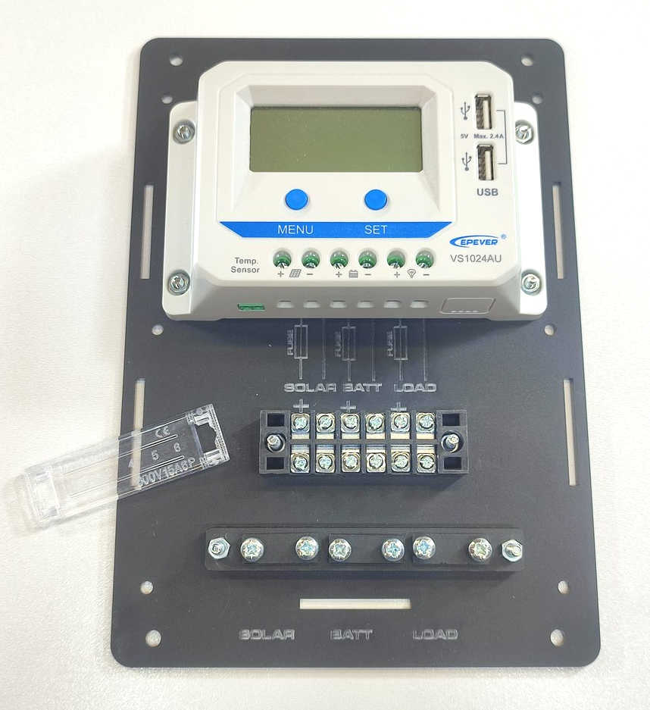 |  | Using the 4x long (22mm) M4 countersunk screws and 4 x M4 nuts the barrier terminal block and the cable clamp unit can be attached to the back plate.  Remove the barrier terminal block transparent plastic cover.  The screws go from the back of the plate and the countersunk heads fits into the countersunk holes on the back.  Use a pair of pliers to hold the nuts to stop it from turning.  Again, you may need to use a small flathead screw driver to hold the nut and stop it from turning, especially for the barrier terminal block.

Step: 5 | Add negative connection wires
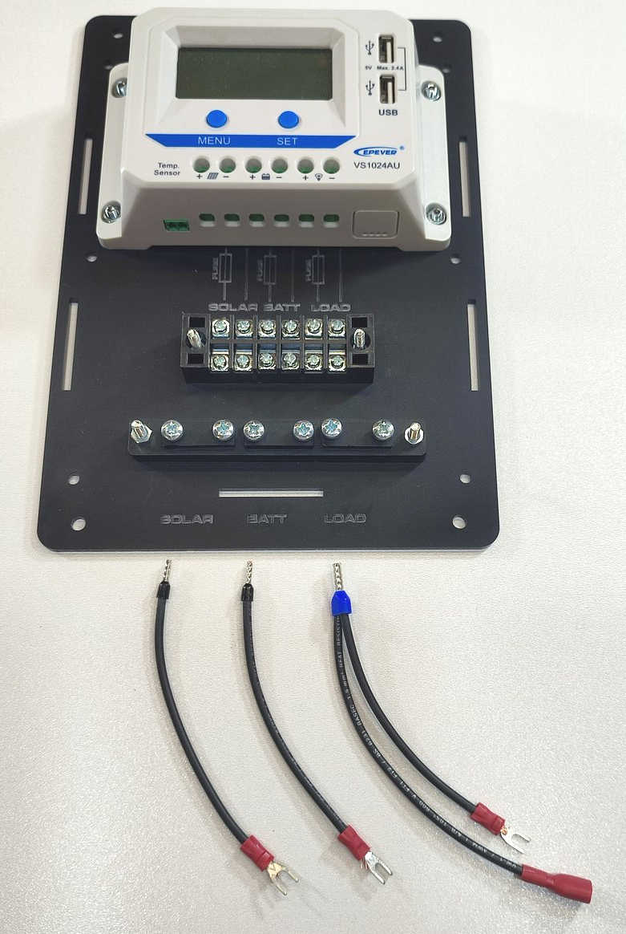  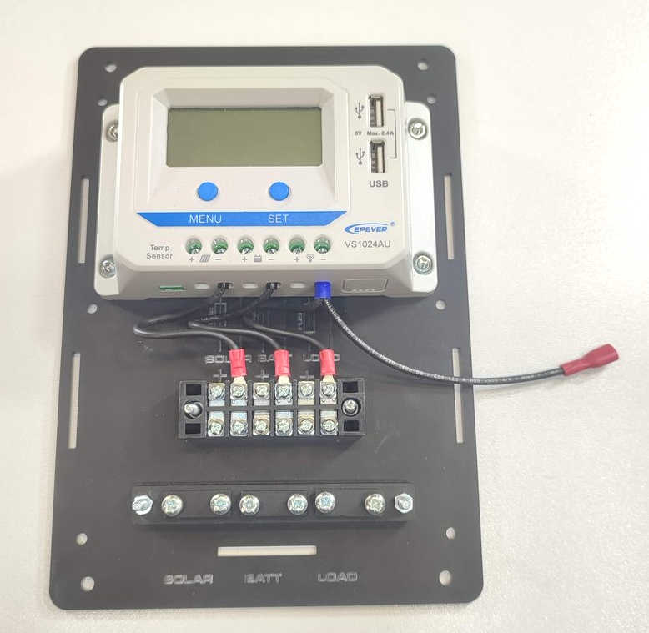 |  | Use the three black cables. Two of them just have a single wire and one of them has two wires.  First use a small flathead screwdriver to add the black/blue wire ends into the charge controller terminals.  The solar and battery have a single wire and these are connected to the solar and batt ‘-’ve terminals.  The load has a double wire – one to the terminal block and one to the power output socket.  The fork connectors are then wired to the barrier terminal block. Follow the engraved labels – the black wires all align with the ‘-’ve connections.  The extra cable with the spade connector (red covered connector) is for the 12V DC socket (step 8).

Step: 6 | Add fuses to front plate
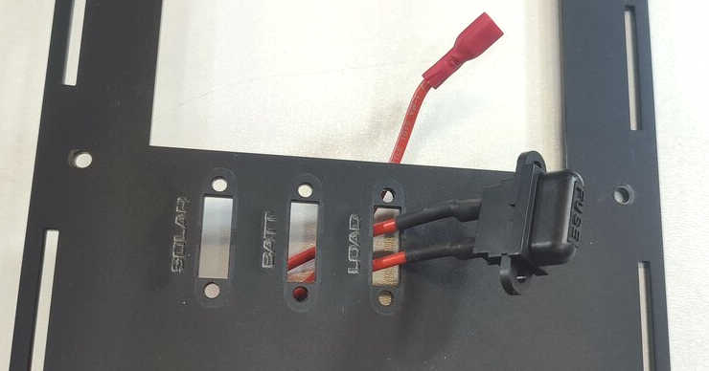  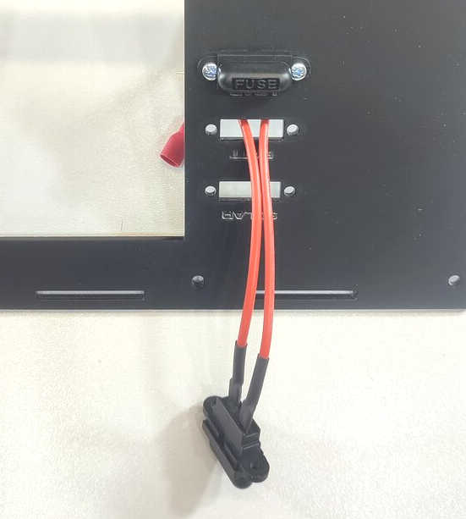  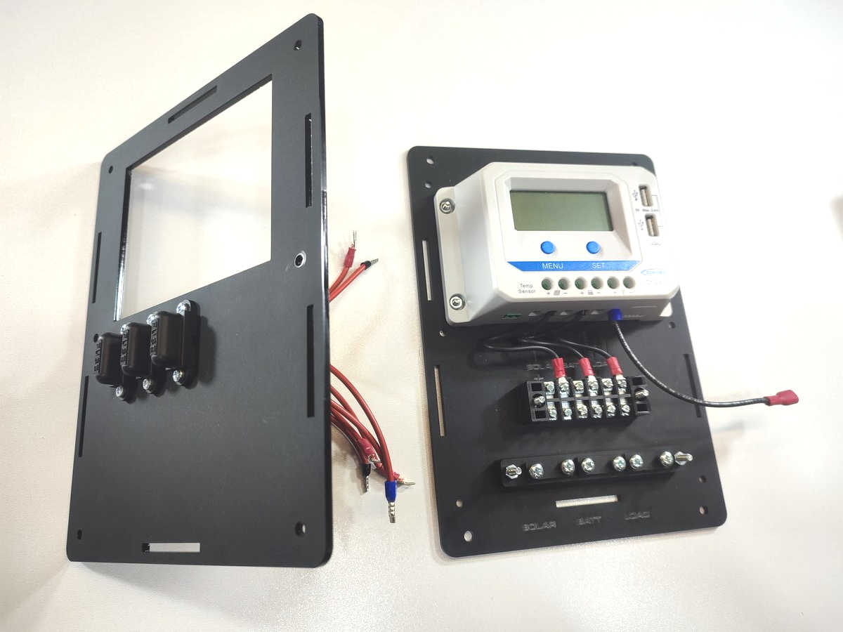 |  | Before you wire in the red wires, first feed the wires through the front panel in the three fuse locations.  The single wire fuses are used for the solar and the battery.  The double wire fuse unit is for the load.  Use the M3 12mm screws and M3 nuts to hold the fuse holders in place onto the front panel.

Step: 7 | Wire fuses to charge controller
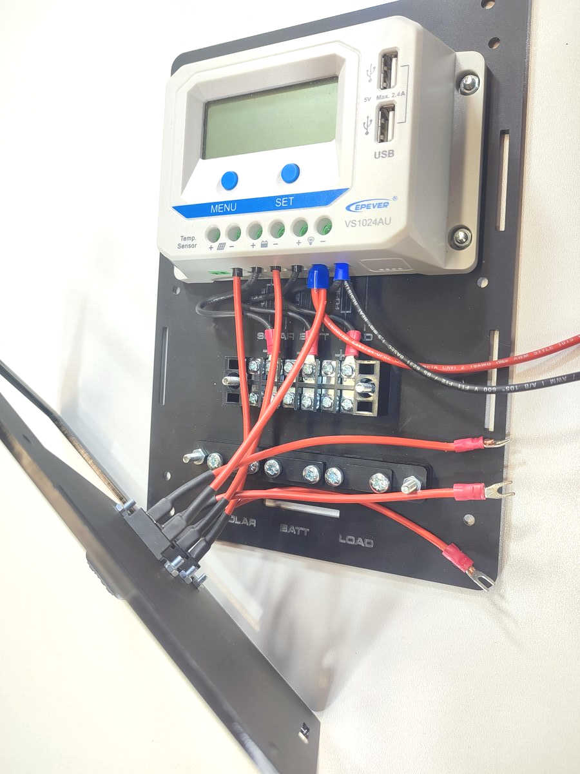  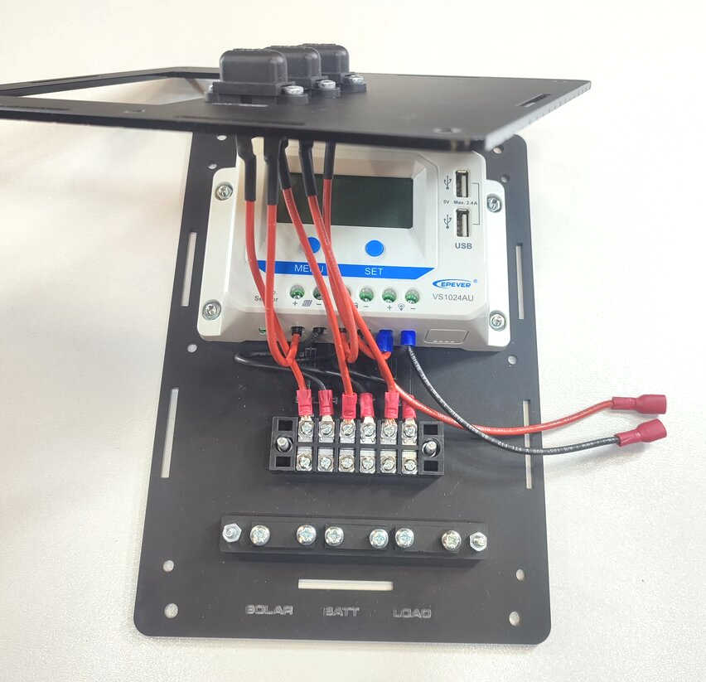 |  | Next the red wires from the fuses are wired to the charge controller and the barrier terminal block.  First add the straight ferrules into the ‘+’ve terminals on the charge controller.  Ensure the correct fuses are used for the inputs to the charge controller. The Load fuse has an additional wire (which goes to the 12V socket).  The fork connectors fit onto the barrier terminal strip. Double check the correct wires align with the engraved labels on the back plate.  The two wires to the DC socket can be aligned to the right hand side of the unit (we will wire this up in the next step).

Step: 8 | Add 12V Socket
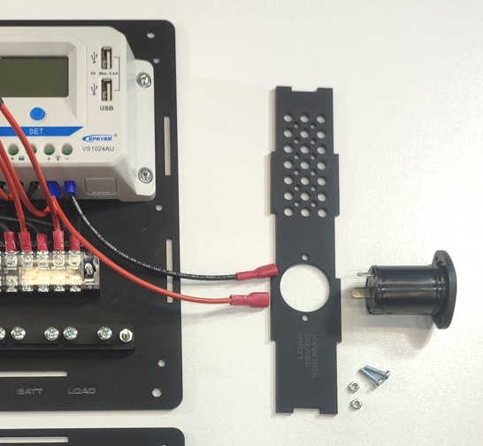  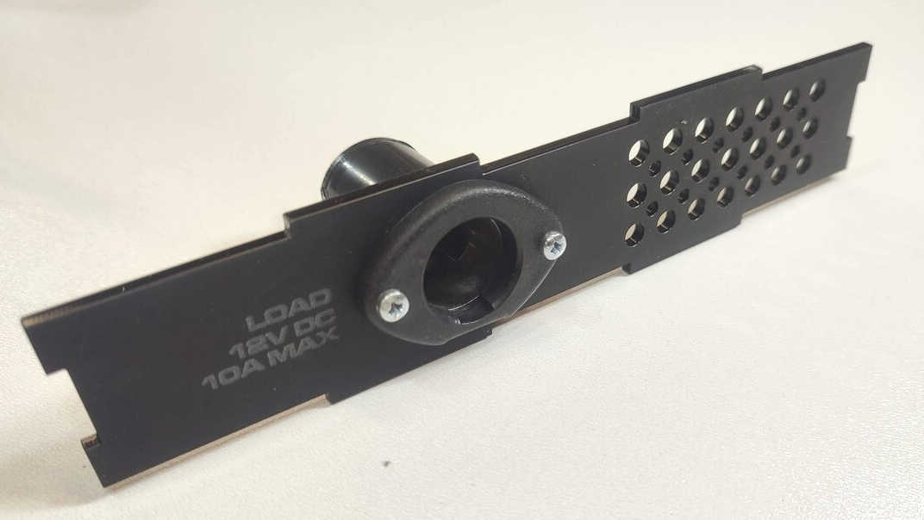  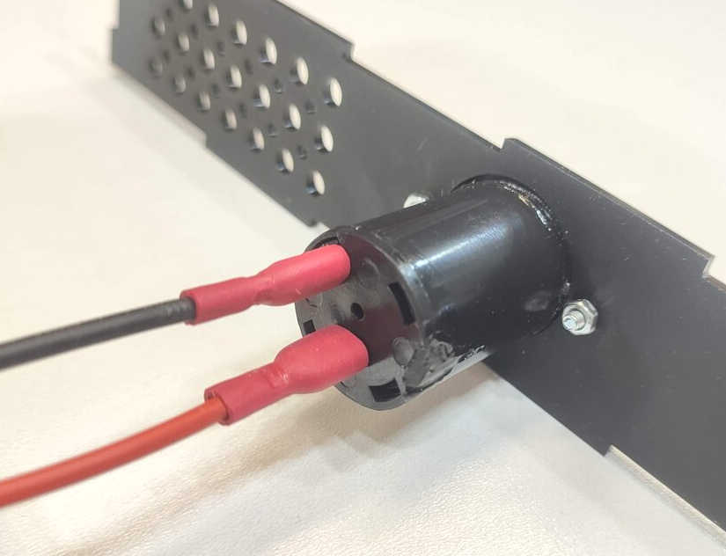 |  | Using the last two M3 12mm screws and M3 nuts, the 12V socket can be fixed to the right hand side plate which has the cut out for the socket.  Ensure that the slight flat edge of the 12V socket goes to the bottom of the right hand side plate.  This means that the terminals of the socket align between the barrier strip and the charge controller (otherwise the may hit the terminal block).  Fit the red wire spade connector to the spade terminal in the middle of the socket unit. This makes the central pin of the socket ‘+’ve.  Fit the black wire to the outer spade terminal of the DC socket.

Step: 9 | Add hex spacers
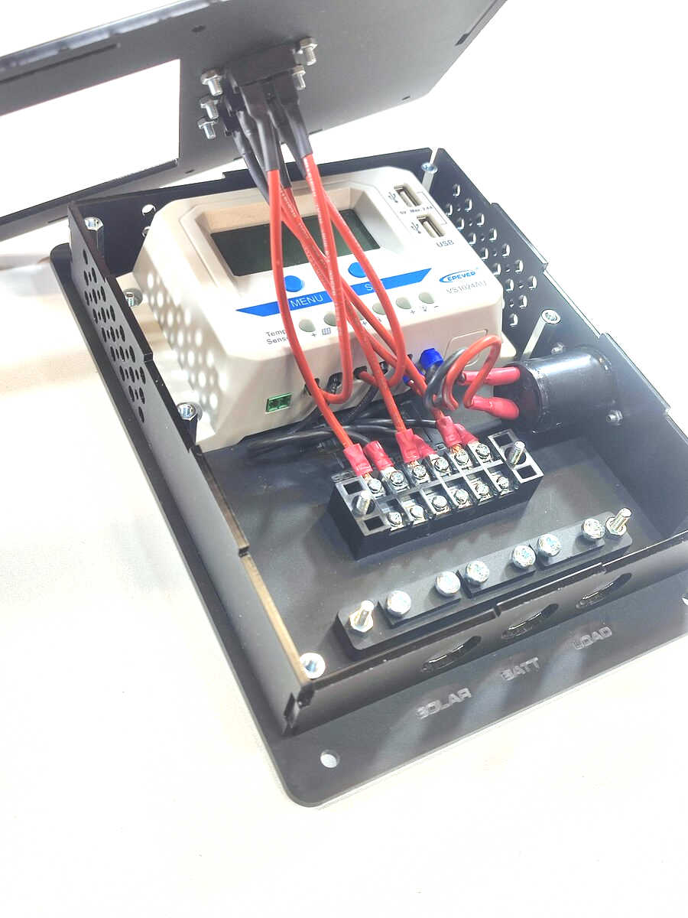  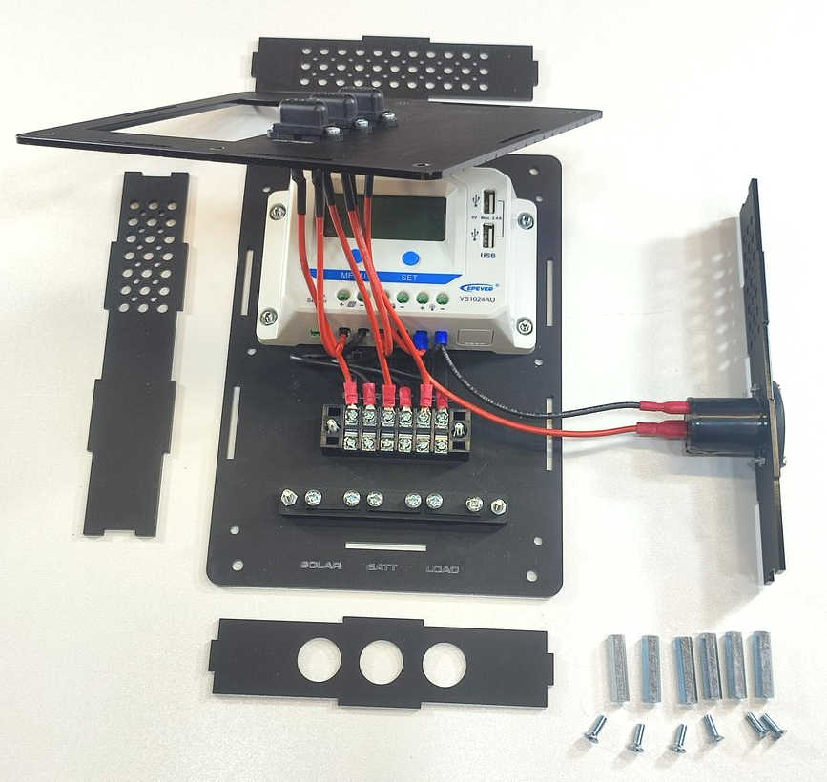  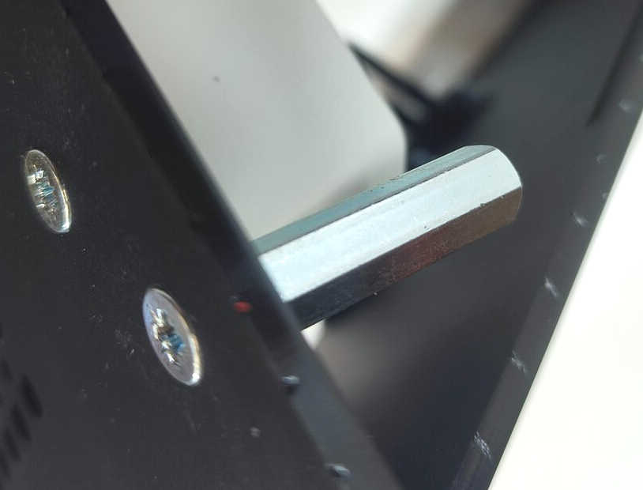  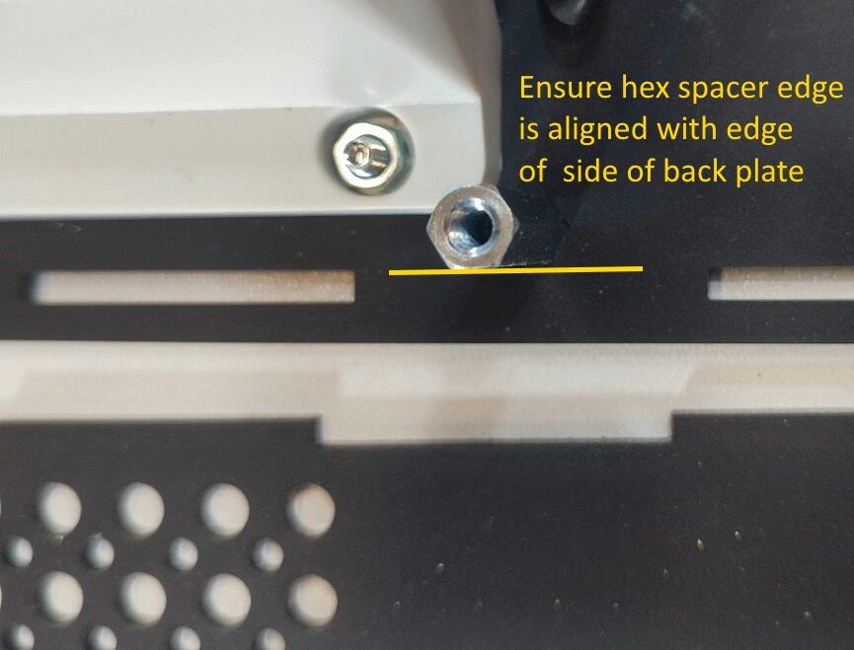 |  | In this step we are using:  6 x M4 10mm screws  6 x M4 30mm hex spacers  The six M4 holes on the back plate will each hold an M4 hex spacer.  The countersunk screws fit through the back plate and hold the spacer in place.  Note: You may need to align the flat sides of the hex spacers with the edge of side of the back panel.  Add the top, lower, left hand side and right hand side panels into the cut out holes in the back plate.  You may need to wiggle and align the cables to ensure the enclosure fits.

Step: 10 | Wire in Solar Panel and Battery
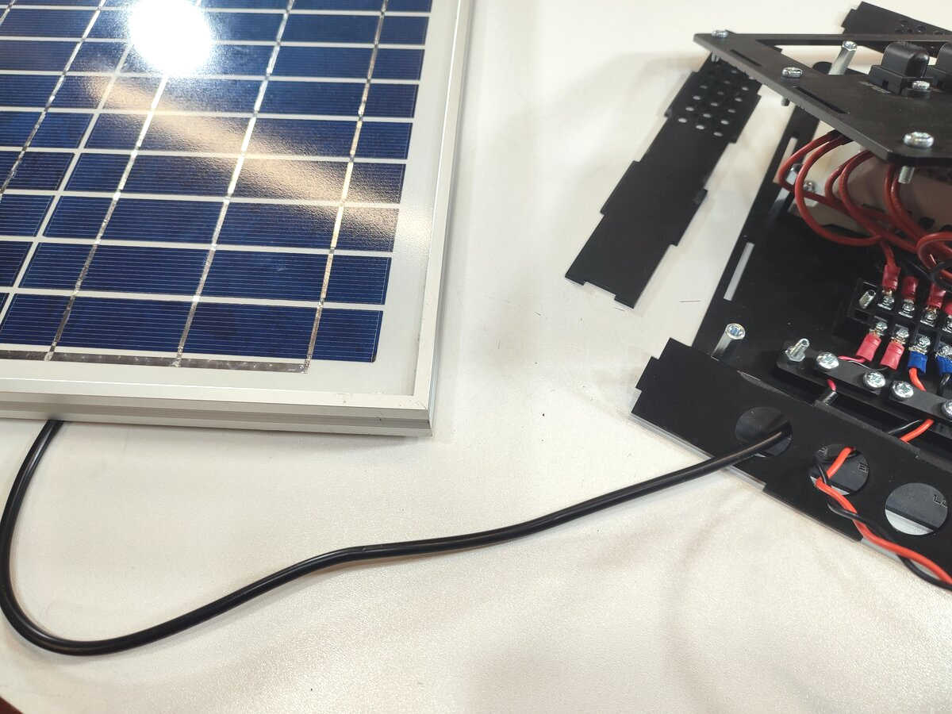  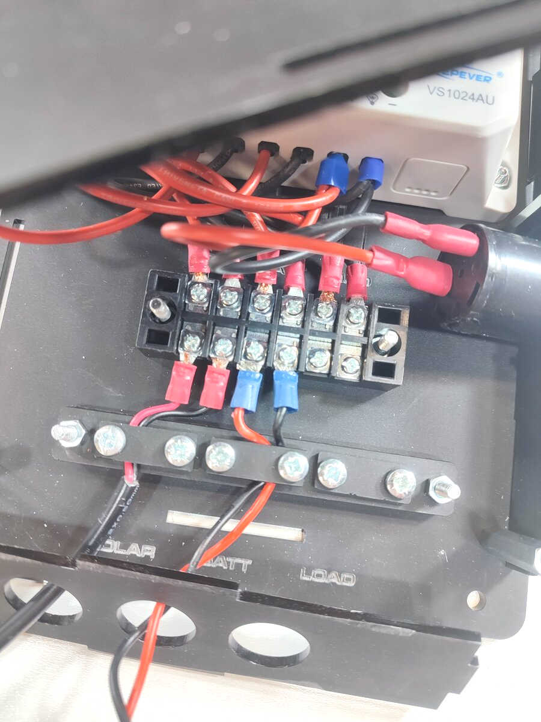 |  | Now you need to wire in your solar photovoltaic (PV) panel and battery cables.  We enclose some fork terminal crimps for your cables.  The MAXIMUM solar current is 10A.  Ensure the solar PV panel is designed for charging a 12V battery (typical open circuit solar voltage is 20-24V DC).  Do NOT use solar PV panels designed for domestic, grid connected inverter-based systems. These typically have higher output voltages and are not suitable here.  Refer to the charge controller manual for full details.  Use decent cable with the correct current carrying capacity (typically 1mm² for every 5A, but this depends upon the cable length.)  ONLY use a 12V lead-acid battery. Sealed, Gel and Open Vented batteries can be used, but ensure you change the charge controller for your battery type.  Please refer to the charge controller manual for more details.  Wire your panel, battery and load (if used) to the barrier terminal block. Use the cable clamps to hold the cables (but don’t over-tighten the cable clamps).  The holes in the base of the unit can have compression glands added for better cable relief. These holes are 20mm diameter.

Step: 11 | Close enclosure
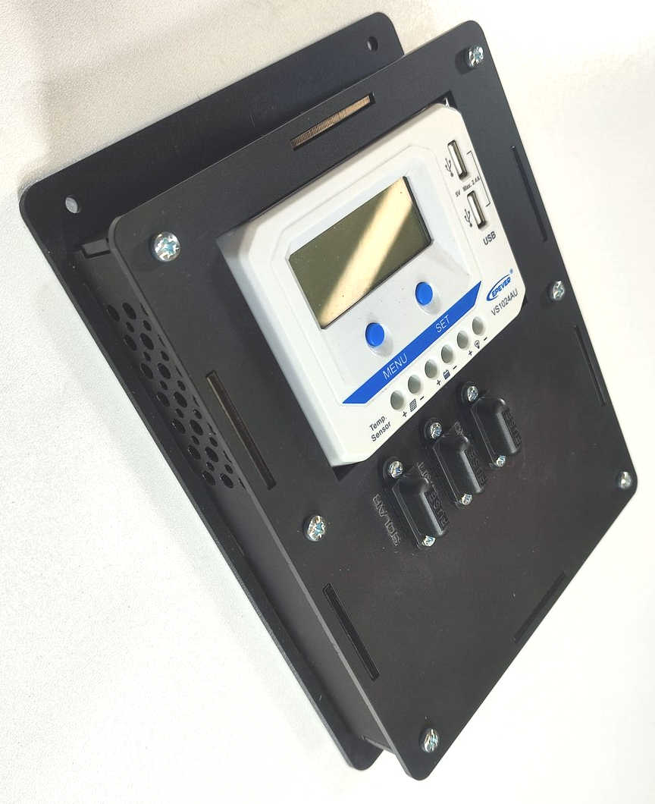 |  | Putting the top on the enclosure is a bit fiddly!  You need to bend and feed the wires so that the top closes correctly.  Do this slowly and carefully so you don’t trap any cables.  Align the cables so the bend to the left hand side where there is more space.  Use the final M4 10mm pan head screws to hold the front plate onto the unit.

Step: 12 | Add fuses
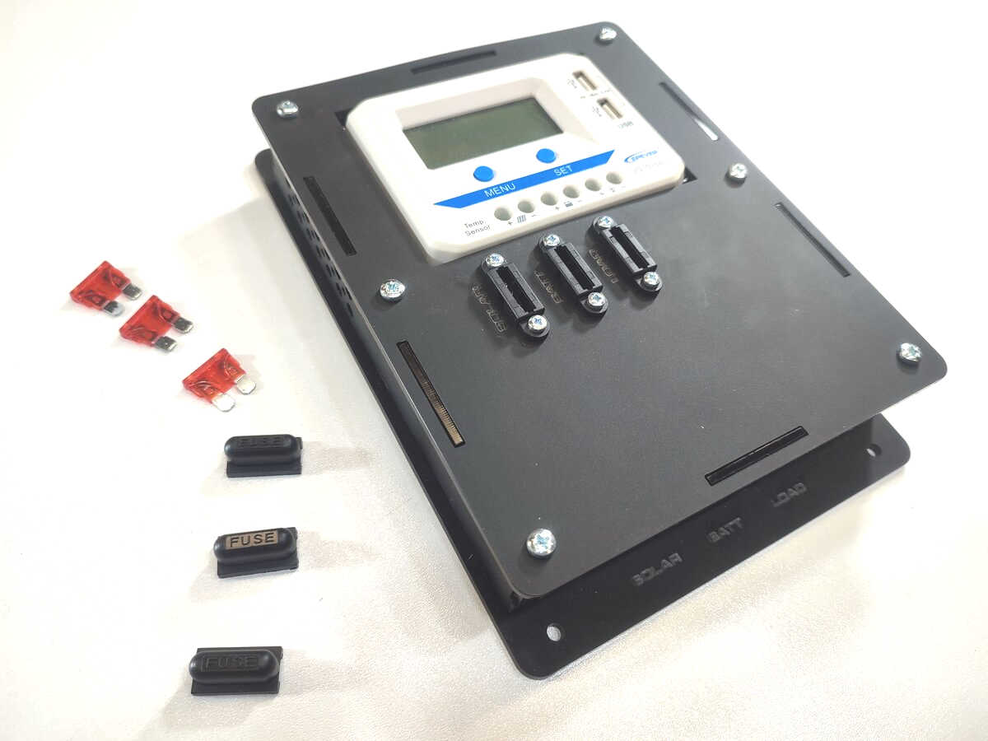  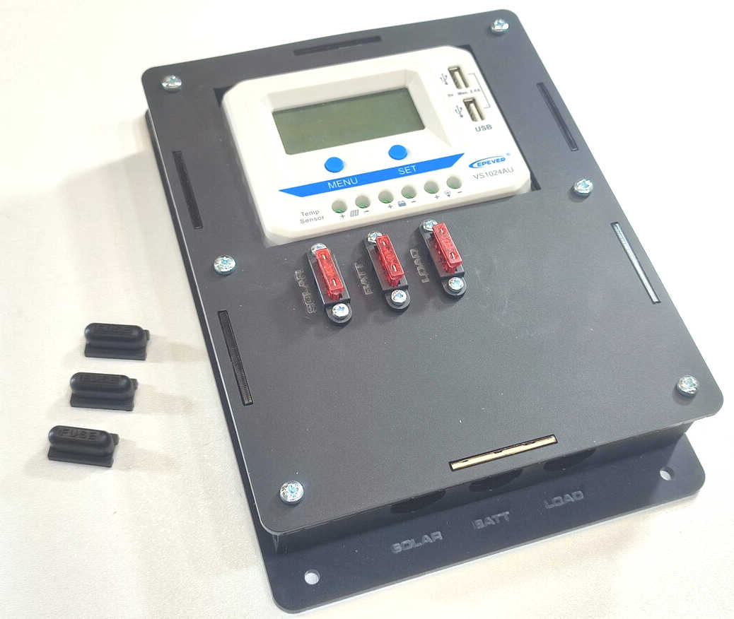 |  | The fuse covers are removed by slightly pushing them with slight force to the left or right. They will then unclip.  Push the blade fuses into the fuse holders.  I usually start with the battery fuse as this means the charge controller will see the battery voltage first and ‘wake up’ in 12V mode.  Then I add the solar and load fuses.  Add the covers back on top of the fuse holders.

Step: 13 | Check operation
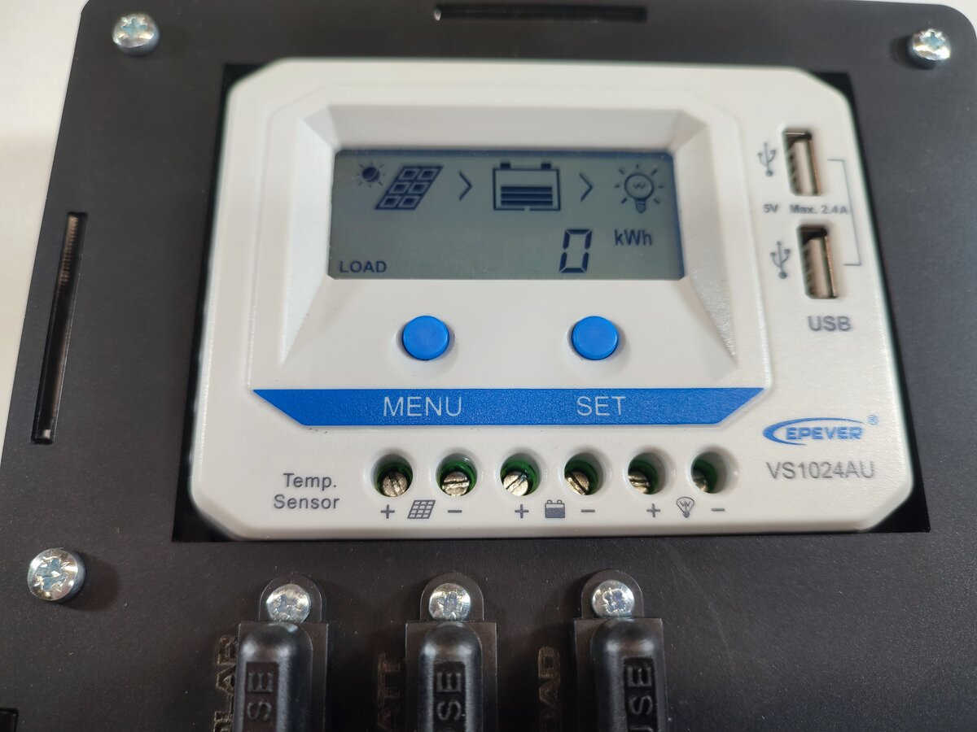  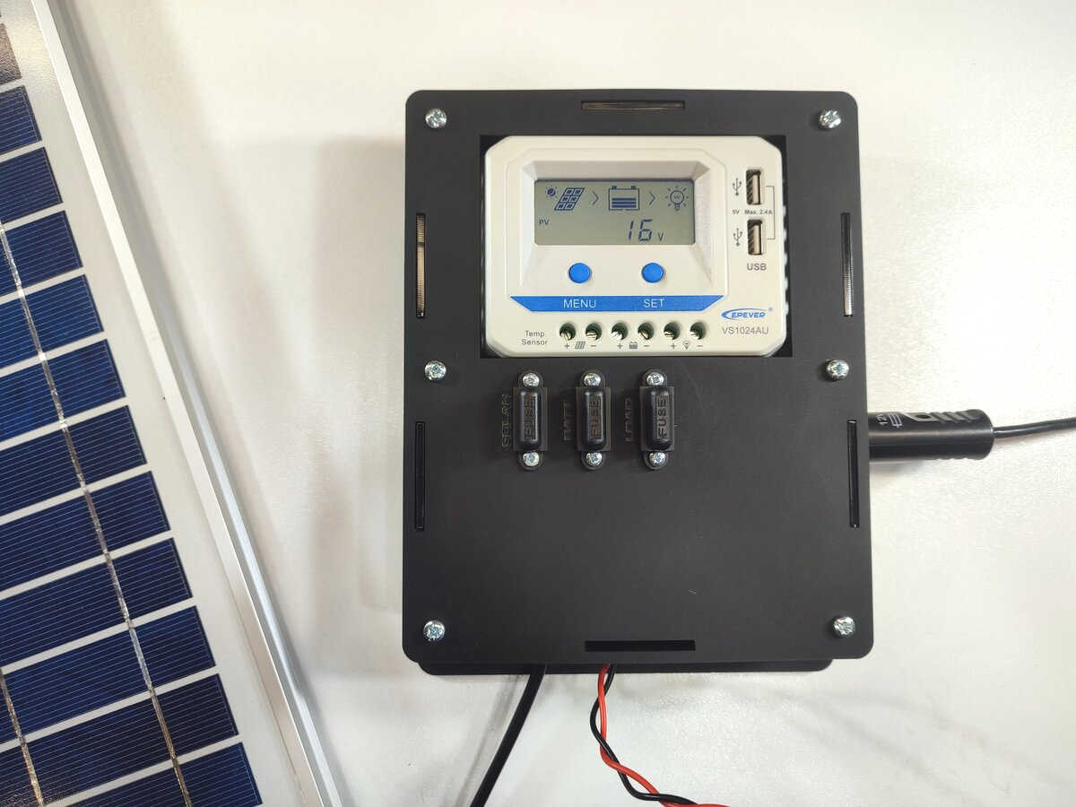 |  | You can now check the functionality of the charge controller. Check the charge controller manual for full functions.  If the solar PV panel is in the sun then you should see charge going into the battery.  If a load is switched on then you should see charge going from the battery to the load.  You can also check the battery voltage.  If needed the charge controller has error codes which can be found in the manual.

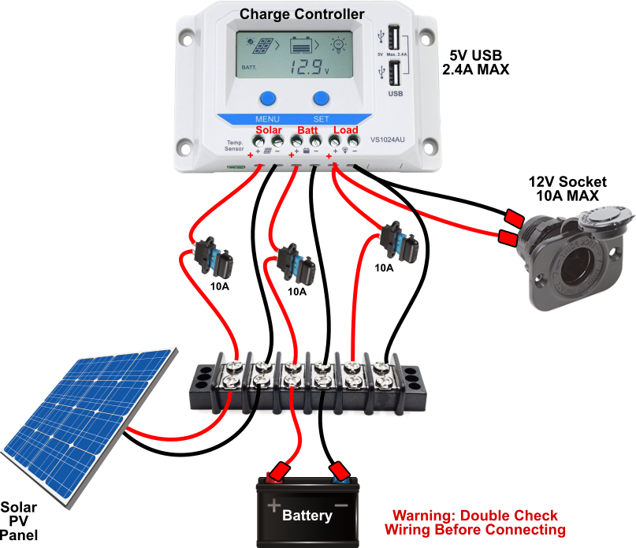

Simple Wiring Diagram

Contact details
We would like you to be happy with this kit. If you are not happy for any reason then please contact us and we will help to sort it out.

Please email hello@curiouselectric.co.uk with any questions or comments.
Please tweet us at @curiouselectric

If any parts are missing from your kit then please email hello@curiouselectric.co.uk with details and, if possible, when and where the kit was purchased.

More technical information can be found via www.curiouselectric.co.uk

This kit has been designed and produced by:

The Curious Electric Company
hello@curiouselectric.co.uk
www.curiouselectric.co.uk

History
This kit was originally developed as a workshop for running educational solar photovoltaic workshops, mainly for Engineers Without Borders UK. Some examples of the workshops run are available here:

https://www.re-innovation.co.uk/workshops/

